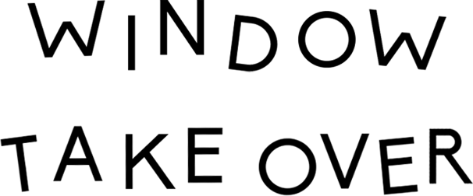
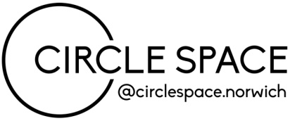

circlespace.norwich@gmail.com
www.circlespace-norwich.com

2021 Information
Thank you for your interest in our window takeover project. To make the most of the space that we have we would like to give local artists the opportunity to showcase their work in our gallery window. The idea of the project is to fill gaps in our programme during this challenging year for public exhibitions and events. This opportunity is free to take part and open to all to submit a proposal for what you would do with the window area for 7 days.
Successful proposals will be added to a list and will be contacted when a gap in our programme appears. While we will aim to give artists as much notice as we can this will not always be possible. Because of this we are looking for proposals that can be delivered at short notice and using pre-existing content. Successful proposals that cannot make a particular date when offered will remain on the list and contacted again when new dates become available.
Window takeovers are installed on Mondays between 2-4pm and removed the following Monday between 12-2pm in line with our event bookings. Once installed you will not have access to your work until the take down. Please make sure you are able to set up and take down your work by yourself (or with help from a member of your household) to comply with social distancing rules or current government guidance at the time.
Please think carefully about creating a durable display that will remain in place for 7 days. Please use suitable fixings, supports or display props that can withstand temperature fluctuations, our window area can get quite hot when the sun is out. (Sticky tape, masking tape or Blue Tac is not sufficient to attach work either directly to the window or used on the back of work for suspension with fishing line from the bar above the window.)
The work displayed can be for sale and you are welcome to create a pop-up shop style display. Where applicable please provide contact details for the public to shop online/contact you directly. Any sales enquiries or transactions are the responsibility of the artist; Circle Space will not act on your behalf or take payments for sales through the Window Takeover project.
The Window area is 2mt long and displays can extend a maximum of 1mt into the gallery.
Circle Space has the following items available for use:
1 low wooden bench
1 wooden topped table with adjustable legs
1 tall free standing easel
1 metal bar attached to 2 existing ceiling hooks for suspending work in the window (light weight work/decoration only)
1 step ladder (not suitable for display, installation purposes only)
Beyond this please provide all your own display stands, materials and signage. This opportunity is for the window area only. No items or fixtures can be attached to the walls or the ceiling outside of the existing hooks and bar system. Lights or other electrical items are not permitted for use in your display.
Participating artists are responsible for the removal of all artwork, display stands, window murals/decoration and rubbish created by their installation by the end of the take down.
To apply, please complete and return the Window Takeover application form to circlespace.norwich@gmail.com. We will get back to you as soon as possible but please be aware that this email address is only monitored Wednesday-Friday’s.
We look forward to hearing from you and good luck!

