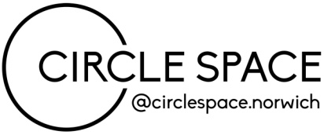

circlespace.norwich@gmail.com
www.circlespace-norwich.com

Application Form
Thank you for your interest in our window takeover project. Please complete this form email it to circlespace.norwich@gmail.com with support images if applicable. Please note, this email address is monitored Wednesday – Friday only, please allow up to 7 days for our reply.
Your details
Name
Phone
Email
Trading Name
Website
Instagram
Facebook

Installation details
Installation / Display description
Please provide web links below to relevant images of your work and/or any previous displays, exhibitions or market stalls. Alternatively, please attach these as low resolution images to you email when submitting your completed form.
I am able to install and takedown my display within the two hour time slots while complying with current social distancing requirements | Y/N
If successful, I am willing to supply a short bio and supporting images for the online promotion of my window takeover | Y/N

We look forward to hearing from you and good luck!

